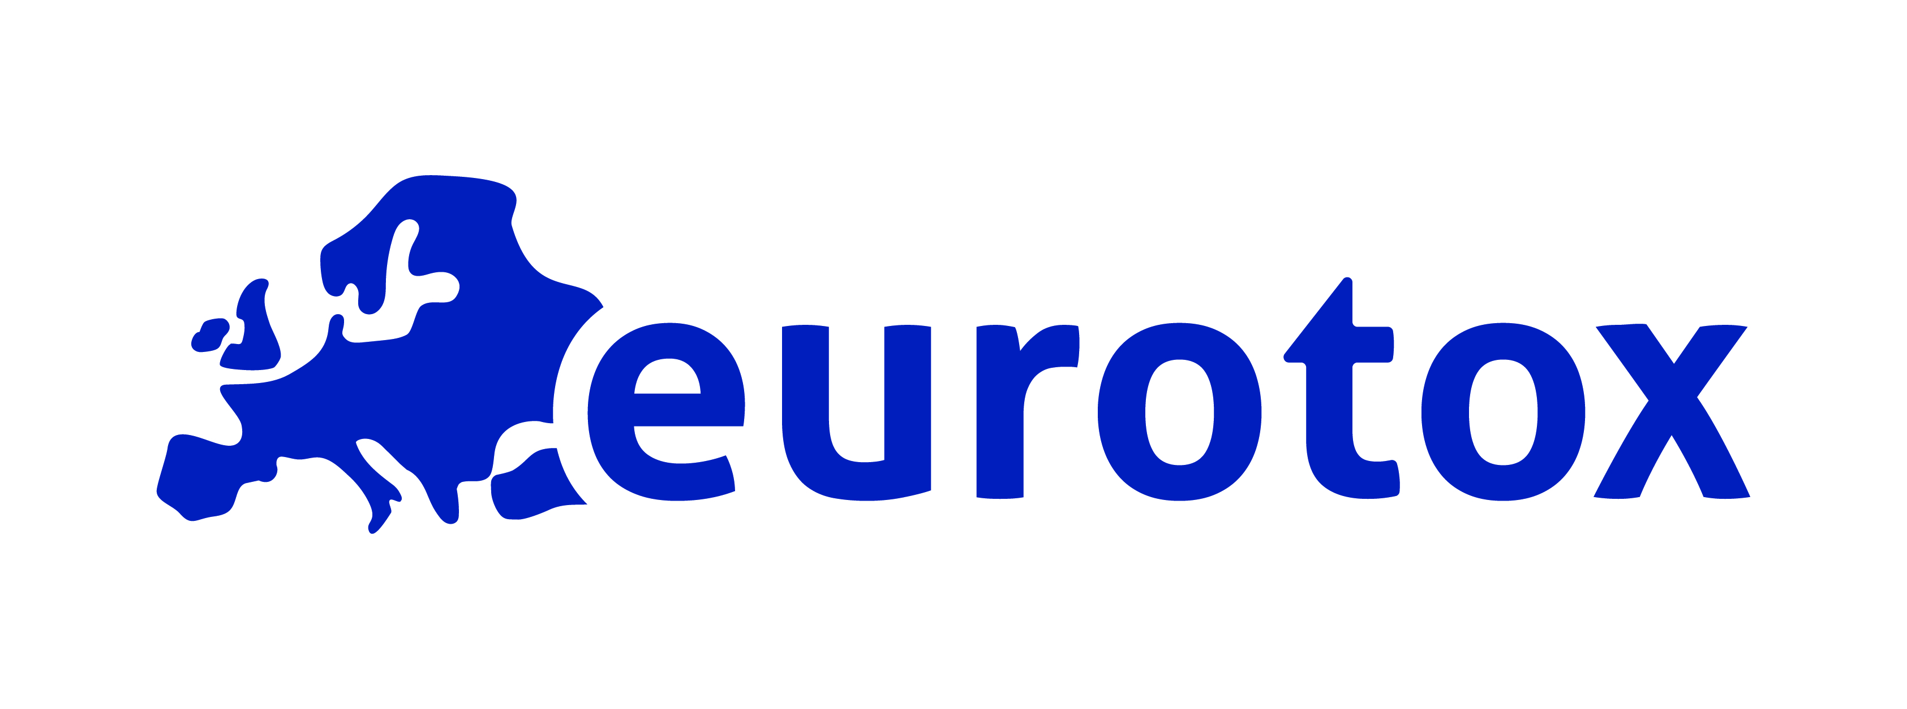
Federation of European Toxicologists and European Societies of Toxicology
EUROTOX offers the opportunity to extend your search by using our reach of member base and media vehicles. In addition to placing the job advert on our website, we will also send out an email to all registered members and national societies via our newsletter. In addition, ads will be posted in our extensive social media network consisting of more than 15 groups targeting toxicologists professionals across Europe. Please send completed form and job advert via email (either in .pdf or .doc format) to secretariat@eurotox.com

General Information
COMPANY NAME |  | TYPE OF ORGANIZATION (check one)  __Private sector __Recruitment  __Governmental __Academic  __Other (specify)__________
ADDRESS
TELEPHONE
FAX
WEB
CONTACT NAME
TELEPHONE
EMAIL

Billing Information
BILLING ADDRESS
DEPARTMENT
CONTACT PERSON
TELEPHONE
FAX
EMAIL

Terms and Conditions
- The fee for a job advert is EUR 800.00 per month, payable within 10 days from the date of the invoice. Academic positions are EUR 100.00 per month. Post docs and internships are advertised free of charge. Special conditions for multiple adverts, or longer posting duration can be negotiated.
- Only one job advert per page. For multiple adverts, each advert should be on a separate page.
- Each job advert is posted for one month (30 days).
- A confirmation email will be sent as soon as the job advert has been posted on the website, followed by an invoice for the appropriate amount.
- Please allow 24-48 hours for posting.

I agree to the terms and conditions,
NAME
DATE

